Data strucher

tree ttierarichal structure

notes

- parents vs children

- siblings

- ancestor vs descentants

binary tree

bst binary search tree

**tree**

- pre-order

-in-order

-Post-order bfs

Dfs

*1- Bfs*

*-Dijkestra*

*-Floyedd shorter path*

*-Beli man-ford*

*Algorithm*

*Liner search binary sontag buble sont*

**Data structure as; array,linked list**

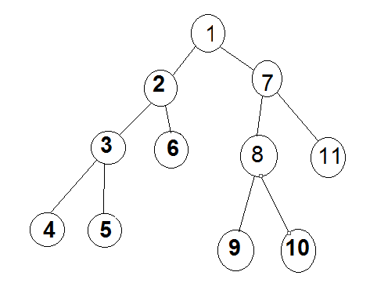***2-Dfs***

***Tree*  special type from data type called graph**

***Tree*  is the simplest from the graph**

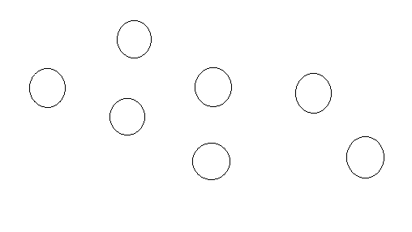**graph**

**- connected vs not connect**

**- directed or undirected ( have no dirction for the edges)**

**- weighted vs no weighted**

**- edge have value**

**- cyclic vs a cyclic**

**- dens vs spowse**

**1- how to implement the graph undirected and weighted by 2D array any matrix array ?**

**2 - undirected and weight put the value of the edges on matrix ?**

**3 – if it is directed and weighted graph by using adjancency matrix ?**

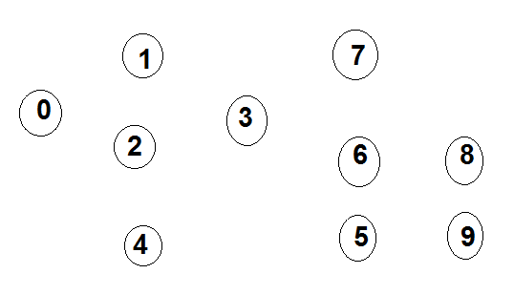**4 – if it is sparse graph have no edges by adjancency list ?**

Code int main(void){

Intg [10] [1] = 5j

g [0] [1] = 5j

g [0] [2] = 2j

g [1] [0] =5j

g [2] [0] =2j

g [5] [6] =3j

g [6] [5] = 3j

adjancecy list

int max (void) {using 52 bytes in memory

structure node {4

int key ;

int weight ; struct node * next ;};

struct node g [10]; g[i]=nul ptr;

struct node g1; g1 key =1

g1 weight=5;

g[0]=g1 struct node g2;

g2key=2

g2 weight =2;

g1.next=g2;}